

SIMATS ENGINEERING
Saveetha Institute of Medical and Technical Sciences Chennai- 602105

Student Name: V.Sri Sadhvik. Reg. No.:192424289.
Course Code: DSA0613. Slot: A.
Course Name: Data Handling and Visualization for Data Analytics
Course Faculty: Dr. Senthilvadivu S & Dr. Kumaragurubaran T

Project Title: Data Handling and Visualization for Business Intelligence

Module Photographs: (3 photographs –Module Photo, Individual student contribution module work in the project and presentation image)
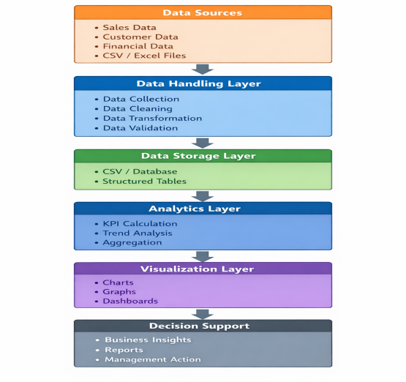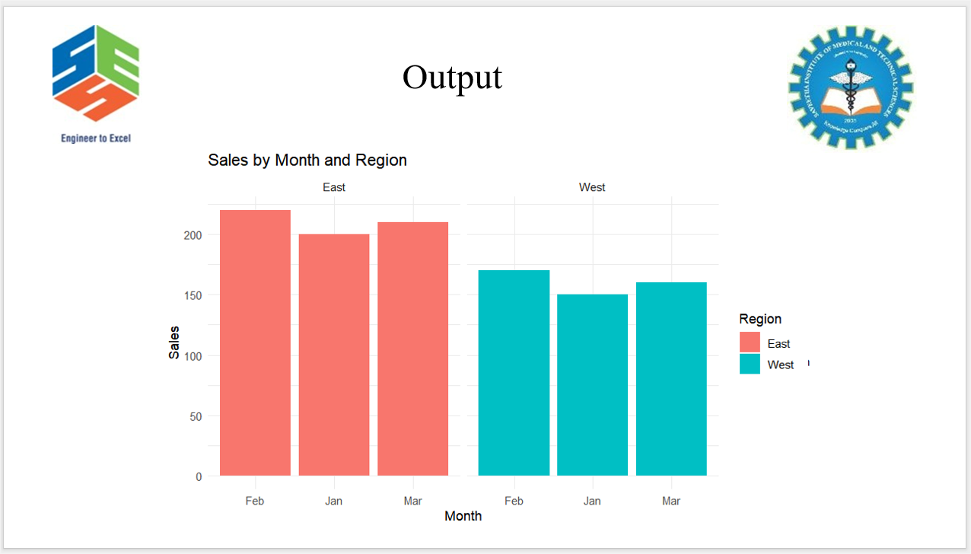
Project Description: (here you write what you did in this project (contribution) including Model Description
Data Handling and Visualization for Business Intelligence focuses on transforming raw business data into meaningful information that supports effective decision making. In modern organizations, large volumes of data are generated from multiple sources such as sales transactions, customer records, financial systems, and operational processes. However, this data is often unstructured, incomplete, or inconsistent, making direct analysis difficult. Data handling plays a crucial role in managing this information by performing processes such as data collection, data cleaning, data transformation, and data validation to ensure accuracy, consistency, and reliability.Once the data is properly handled, business intelligence techniques are applied to analyze key performance indicators and identify trends, patterns, and relationships within the data. Data visualization enhances this process by presenting analytical results in graphical formats such as bar charts, line graphs, pie charts, heatmaps, and dashboards. These visual representations simplify complex datasets and allow decision makers to quickly understand business performance, compare results across regions or time periods, and identify areas that require improvement.By integrating structured data handling with effective visualization techniques, this approach reduces manual effort, minimizes errors, and improves the speed and accuracy of business decisions. The system enables organizations to monitor performance, forecast future trends, and develop data-driven strategies. Overall, Data Handling and Visualization for Business Intelligence serves as a powerful tool that converts raw data into actionable insights, supporting organizational growth, efficiency, and competitive advantage.+

Student Signature Guide Signature

